**CIS 5690 – Advanced Systems Project**

**UML and ER Diagrams**

**This document consists of following diagrams**

1. **Use Case Diagram**

Use Case diagram is drawn on

<https://www.gliffy.com/go/publish/4439809/>

1. **Sequence Diagram**

Sequence diagram is drawn on

https://creately.com/app/?tempID=gc7qvpsj1&login_type=demo#

1. **Activity Diagram**

Activity diagram is drawn on

https://creately.com/app/?tempID=gc7qvpsj1&login_type=demo#

1. **Entity-Relationship Diagram**

**ER diagram is obtained from PHPMyAdmin under designer which shows entity relationship between tables and primary – foreign key relationship**

**Use Case Diagram**

**Use Case Description**

**Client** will register to system after registering he can purchase product check billing details invoice amount, create ticket if he has problem, check status of ticket if create and can logout.

Staff will login to system check customer details if client call for inquiry, check invoice , create ticket, update ticket, close ticket.

Admin can do all ajobs as client and staff above that admin can manage roles for registered users and designate them if they are client, staff or admin.

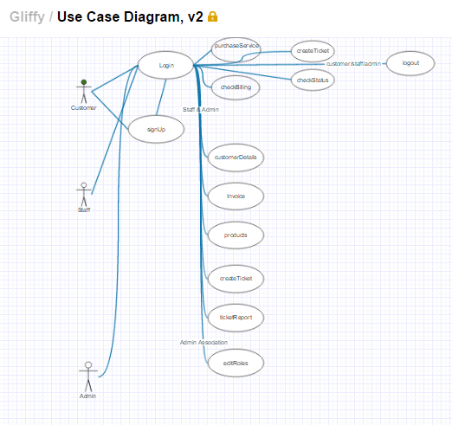

**Sequence Diagram**

**Client Sequence diagram**

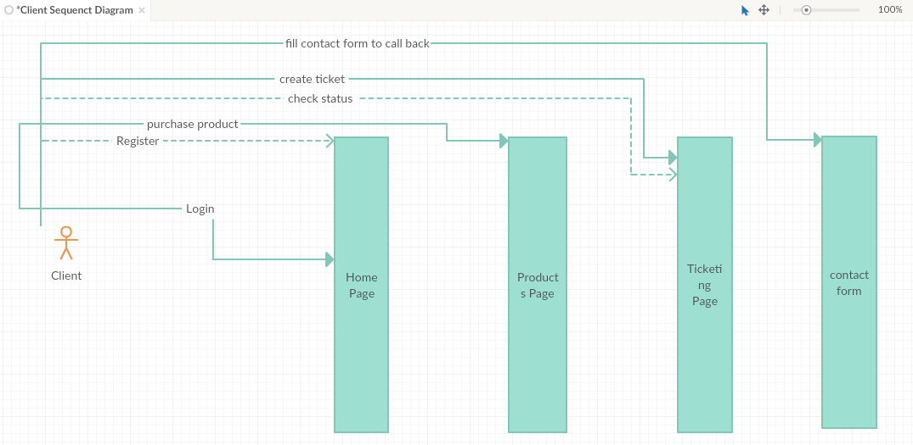

**Staff Sequence diagram**

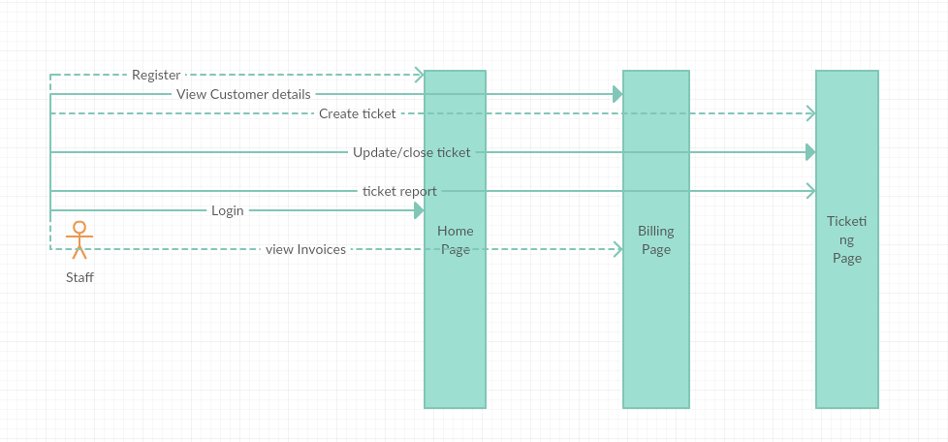

**Admin Sequence Diagram**

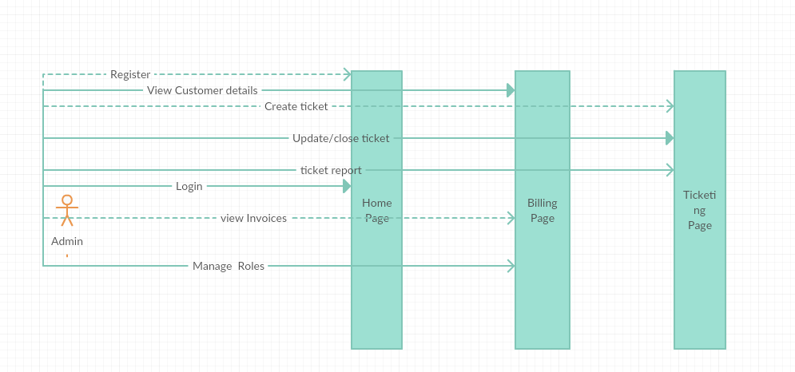

**Activity Diagram**

**Client**

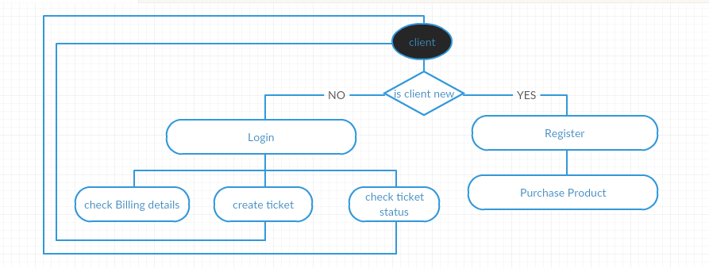

**Staff**

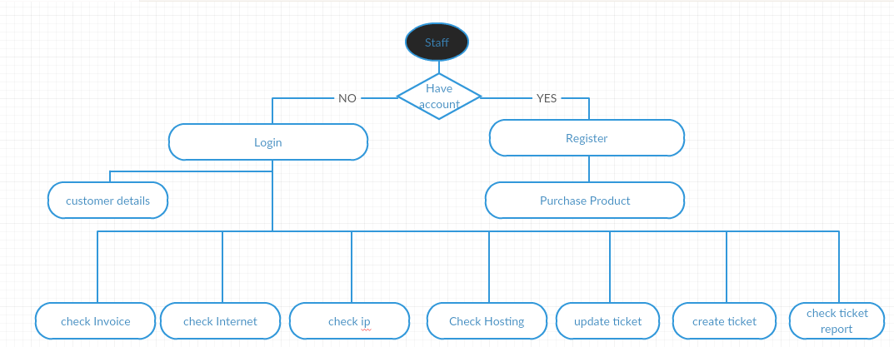

**Admin**

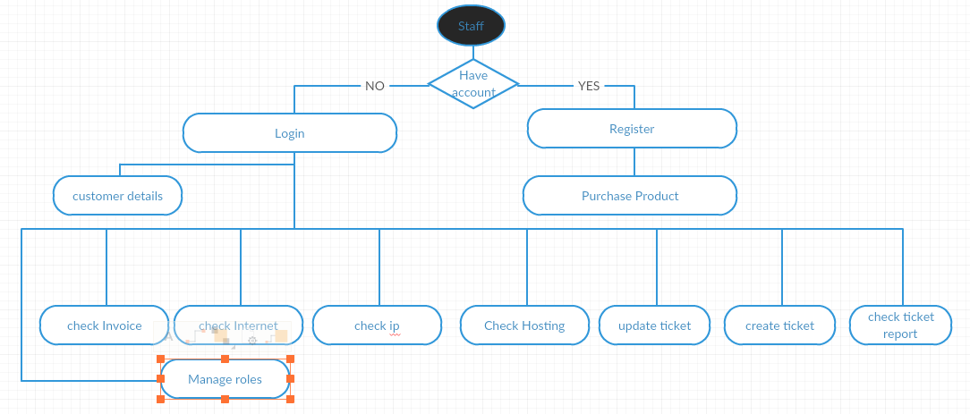

**Entity-Relation Diagram**

